Senior Solutions

Joseph Valentine, Aaron Mills, Alejandro Carvajal, Alexander Berry, Natalie King

CEN 4010

Dr. Bullard

Florida Atlantic University

Table of Contents

Motivation Statement ……………………………………………………………… 3

Group Members ………………………………………………………………….. 3

Stakeholder Definitions ………………………………………………………….. 3

Statement on Development Model …………………………………………….. 4

Statement on Distributed Model ……………………………………………….. 4

Statement on Security …………………………………………………………… 4

System Architecture Model …………………………………………………….. 5

User/System Requirements …………………………………………………….. 5

Use-Case Diagrams …………………………………………………………….. 8

Sequence Diagrams …………………………………………………………….. 9

Class Diagram ……………………………………………………………………. 13

User Interface Diagrams ………………………………………………………… 15

Database Design Diagram ……………………………………………………… 16

Glossary …………………………………………………………………………… 17

Poster …………………………………………………………………………….. 18

Brochure ………………………………………………………………………….. 19

User Guide ……………………………………………………………………….. 20

Resumes ………………………………………………………………………….. 25

Research Paper ………………………………………………………………….. 32 Motivation Statement

For starters, the problem is that West Boca Retirement Community does not have an efficient system to access resident information, request services, view upcoming events, and more. The solution to this problem is to create a website where residents in the community will be able to visit one location online in order to view or change anything related to the retirement community. It will also allow management to control different aspects of the website without any prior IT experience. This is extremely important to the team because we all have parents who are entering this age group and we would like to help give back to the generation that gave so much to us. Therefore, we will be highly motivated to complete a superior and reliable system for West Boca Retirement Community.

Group Members

|  |  |  |
| --- | --- | --- |
| Group Member | Title | Contact |
| Joseph Valentine | Project Manager | [jvalentine2020@fau.edu](mailto:jvalentine2020@fau.edu) |
| Aaron Mills | Documentarian | [millsa2020@fau.edu](mailto:millsa2020@fau.edu) |
| Alejandro Carvajal | Backend Developer | [acarvajal2021@fau.edu](mailto:acarvajal2021@fau.edu) |
| Alexander Berry | Frontend Developer | [aberry2017@fau.edu](mailto:aberry2017@fau.edu) |
| Natalie King | Tester | [nking2018@fau.edu](mailto:nking2018@fau.edu) |

Stakeholder Definitions

|  |  |
| --- | --- |
| Stakeholder | Definition: System Interactions |
| Community Staff | Manage databases, access residents’ information, handle payments, provide services, host events, etc. |
| Software Developers | Build, document, update, and maintain |
| Possible Investors | Support financially, receive partial ownership |
| Residents | Manage residential information, payments, events, services, activities, etc. |
| City Officials | Benefit from the impact of the software on the community |

Statement on Development Model

For the most part, the team has taken a Waterfall, plan-driven approach. We have divided the tasks to separate and distinct phases, since each component depends on the last. This method has proven to be effective for us due to the component dependency and flow of our work. That is, we prioritize the specification and development, then present documents at the end. Though our system is built centered around the Waterfall model, we are not opposed to implementing tactics from others.

We have considered integrating and configuring existing components, the reuse approach, but felt originality was essential. However, if at any point in time it seems in our best interest to configure pre-existing elements to enhance the user experience, the necessary steps shall be taken.

The Agile (scrum) method would not be appropriate for a variety of reasons. To list a few, team members’ schedules cannot accommodate frequent scrum meetings, a scrum master cannot protect our members from outside interferences, stakeholders cannot be involved in validation until the end, minimal documentation is not plausible, and more. Though, we must work swift and diligently to meet our deadlines.

Despite the fact that we implement software fractions in increments, the nature of the Incremental development model itself does not suit our project. This is because we do not need to accommodate much change and customers shall not view the product until it is complete.

That being said, because requirements are well-defined, a suitable plan has been generated, and phases have been discussed; the linear workflow that is the Waterfall method appears to be most optimal for our system. However, pieces of other models may be incorporated along the way, as well.

Statement on Distributed Systems

What makes our system a distributed model is that while our system may not have a single authority in charge, it can be maintained across multiple computers. When one programmer manages the databases, another would work on the user interface. Additionally, the system build encourages openness via the usage of a web server, where unique components may be integrated with the proper protocols. The web server is a major component as it also allows us to disperse components with ease, thus promoting scalability. Additional services/features can be implemented, managed,  and uploaded to the server in a seamless manner.

Statement on Security

At Senior Solutions, we value privacy and security. Our system shall protect all user data, including passwords, usernames, and other credentials. This information is important as it protects users against fraud. Using credentials, hackers may be able to access medical information, credit scores, and other confidential information; this is why we value protecting personal data. We do this by incorporating a hashing algorithm which utilizes a 120 (8-bit) key to encrypt. This key is then used to do 100 passes, thus creating as much randomness as possible while still being decryptable by us. This protects against cross-site forgery attacks, in which case attackers can access databases from the website. Our security policy is that even if somehow the database is breached, protection shall still be ensured because the critical information is not stored in plain text. The attacker would need to know our specific hashing algorithm.

System Architecture Model

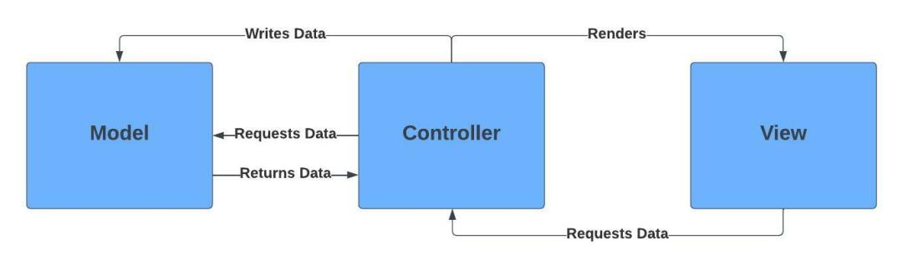

User Requirements

|  |  |
| --- | --- |
| User Requirements | System Requirements |
| **1.** The user shall be able to access and alter their account information with their credentials | **1.1** Upon entering the correct identification information; the user shall be able to view, update, and confirm resident information.  **1.**2 They shall also be able to update their personal information from this account page  **1.3** Each users’ profile shall differ depending on their role. Mainly, residents and visitors shall have the ability to request and view services, while staff members have the ability to create and remove content  **1.4** All users shall have specific credentials; community members shall have a license key generated by staff members  **1.5** A checklist shall be incorporated and made available to applicants to ensure completion of the registration process  **1.6** Members shall be able to post, edit, vote and comment community issues from their personal page via a blog  **1.7** Privacy and protection shall be taken into consideration through the creation of an authentication feature |
| **2.** Managers shall be able to register various events for a future specified date and time from the event subsection of the activities page | **2.1** Utilizing a calendar, event planners and managers shall have the ability to select a date and time when registering an event  **2.2** The calendar shall NOT allow users to assign activities to dates from the past  **2.3** Users of this event planning feature shall have the option of mapping activities to dates and times for specified and multiple groups, such as: new residents, employees, visitors, etc.  **2.4** Some types of events planners shall be capable of posting include: new, current, community.  **2.5** In addition, the client party shall also be granted the ability to post transportation information; for instance, car pool and bus schedules  **2.6** Residents and visitors shall be able to view their personal and general events on the virtual calendar  **2.7** In the clubs section, staff members with permission shall be able to create and remove clubs for others employees, visitors, and residents to join  **2.8** Staff members will also have access to their personal payment schedule |
| **3.** A survey system shall be implemented, where staff members can post virtual questionnaires, which can be closed at any time | **3.1** Authorities with granted permission shall be capable of posting surveys, questionnaires, and polls  **3.2** Survey creators shall have the option of specifying whom is allowed to participate in the event  **3.3** Employees shall have the ability to be chronologically discrete or continuous, meaning they can have specified closing dates or not  **3.4** Staff members shall have the option of re-opening surveys  **3.5** There shall exist an option to allow survey creators to specify whether to corresponding results will be public or private, with private results reserved only for staff members  **3.6** Visitors and residents shall be granted viewership to their individual questionnaire submissions  **3.7** The survey feature shall be organized in such a manner to be visually appealing and simple to encourage participation |
| **4.** A trustworthy payment system shall be incorporated, allowing residents to shop and pay the appropriate fees | **4.1** Financial officers shall be able to check to ensure that initial deposit of community fee has been paid and collect deposit if not paid  **4.2** Officers shall be able to confirm whether certain fees had been paid and collect them  **4.3** If fees had not been paid, the user shall receive a message notifying such  **4.4** Members shall be able to make payments utilizing a plethora of methods, including PayPal, credit card, etc.  **4.5** Staffs shall be paid using this system, as well |
| **5.** Database(s) shall be implemented to assist staff representatives in handling community information | **5.1** Staff members shall be able to log visitors and access their information  **5.2** Managers shall be able to manage a database of resident information  **5.3** Financial officials shall have access to staff wages |
| **6.** A service management feature shall be implemented, allowing for residents to request and comment on community provided services | **6.1** Residents shall have the ability to request community provided services with or without an additional comment  **6.2** Residents shall be provided the option to submit complaint forms about various topics |
| **7.** An about page shall be created, which will include general information about the business | **7.1** A general business page shall be implemented to include the organization’s summary, objective, history, and contact information |

Use-Case Diagrams

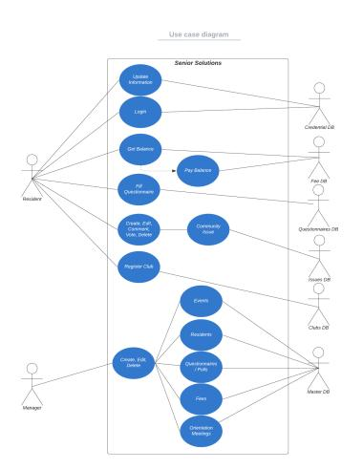

Sequence Diagrams

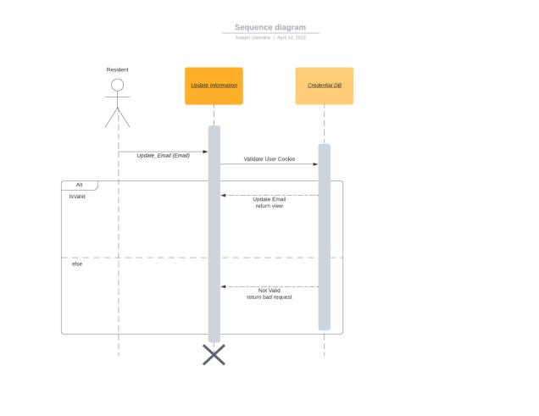

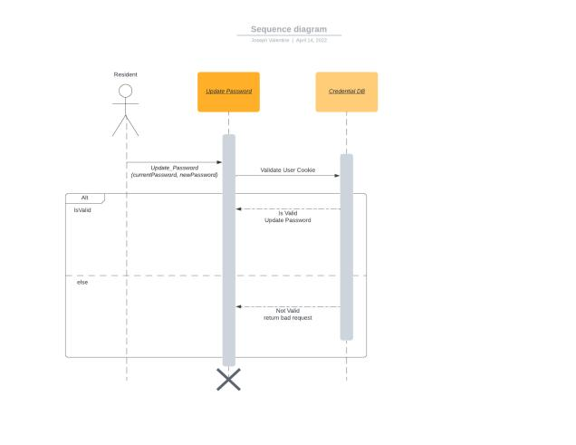

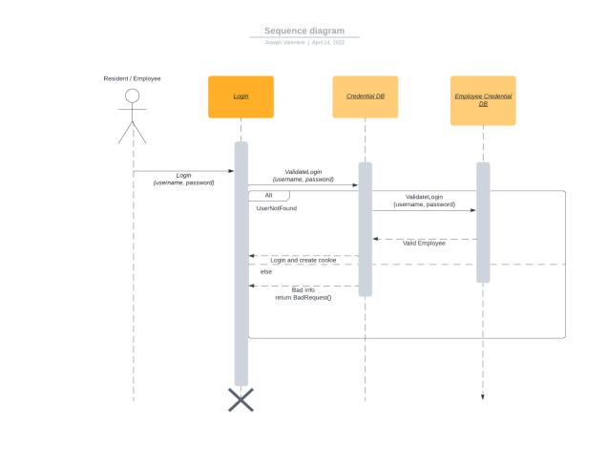

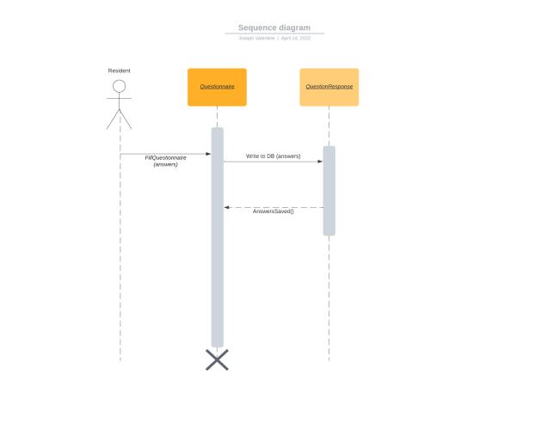

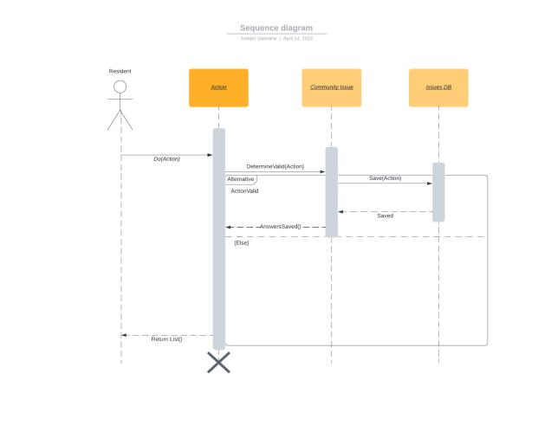

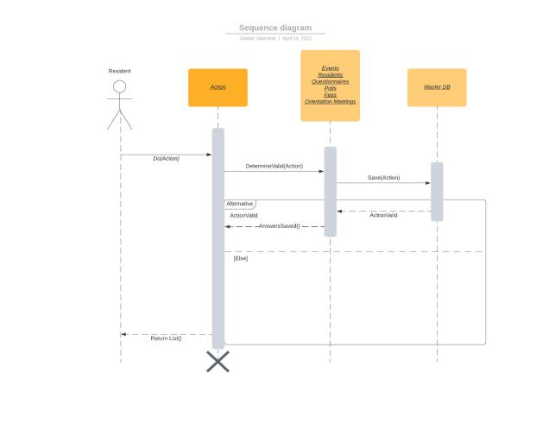

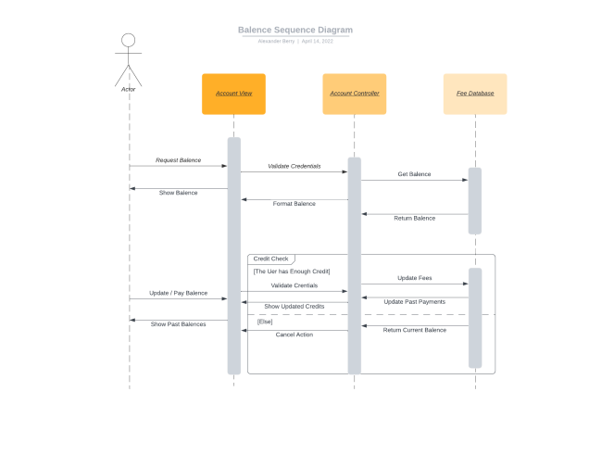

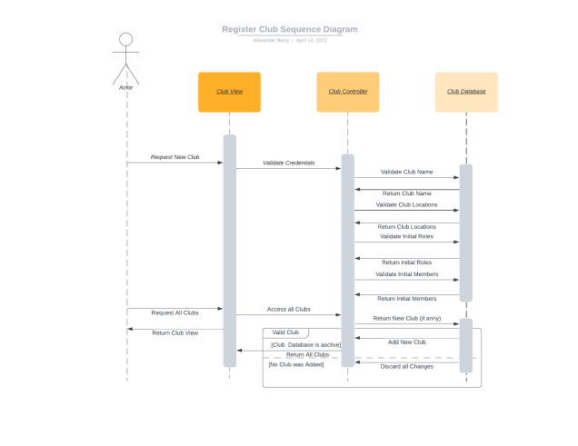

Class Diagrams

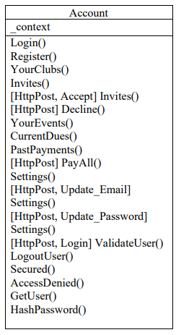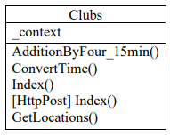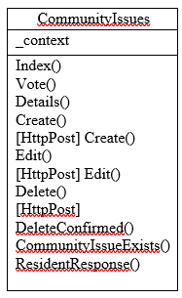

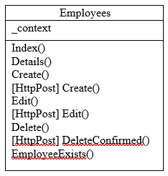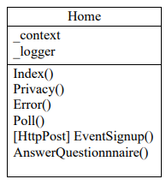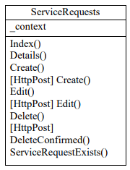

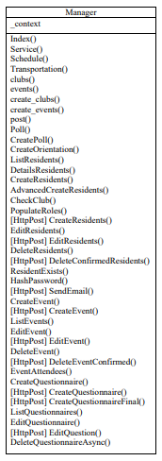

User Interface Diagrams

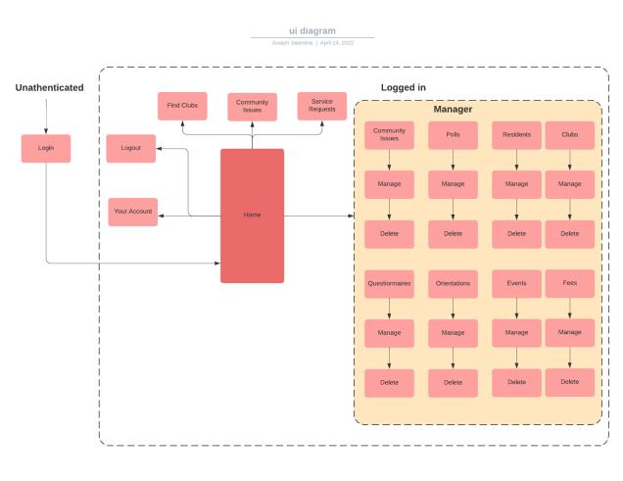

Database Design Diagram

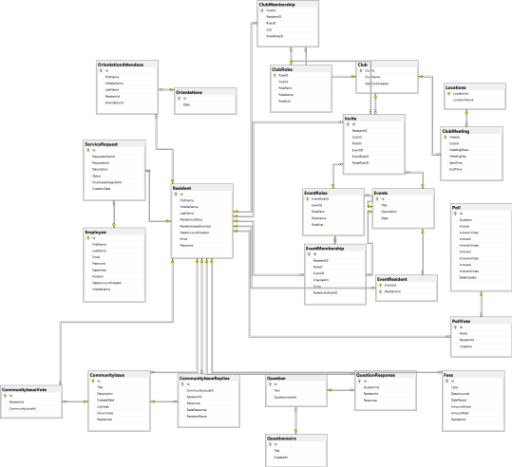

Glossary

Database - location in computer where information may be stored and/or manipulated

Decryption - the process of transforming encrypted data so that it may be accessed

Distributed System – a system that has multiple runs on different computers rather than a single individual in charge

Encryption - the process of providing security by randomizing data so that only authorities may

access it

Openness - a system is high in openness if many unique components integrated by different

programmers utilizing an agreed upon standard

Robustness - how well the system responds to errors

Scalability - the ability of the system to be updated to accommodate for rising system demands with quality services

Scaling out - the addition of more resources

Scaling up - increasing the power of current resources

Security - the ability of the system to defend against cybersecurity attacks

Smart System - a system (software or hardware) which utilizes data to automate tasks, nearly replicating human intelligence

Poster

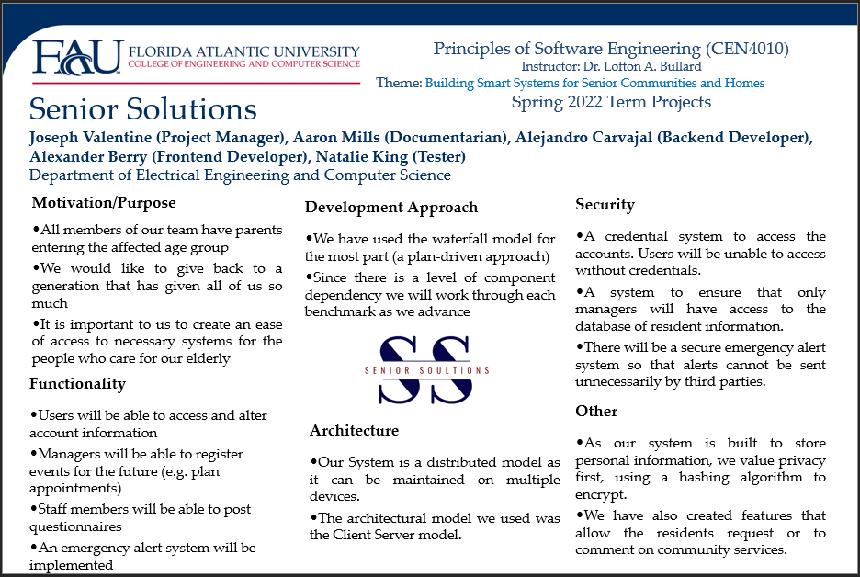

Brochure 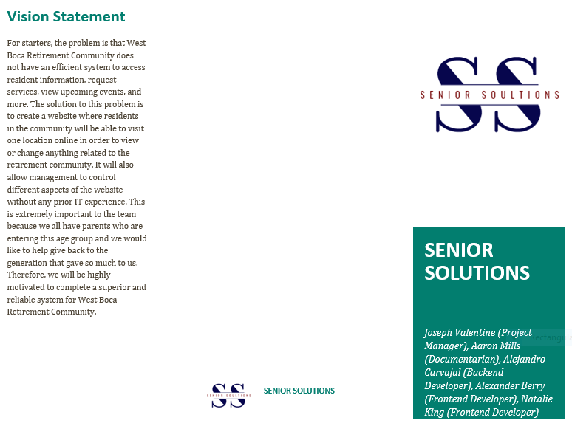

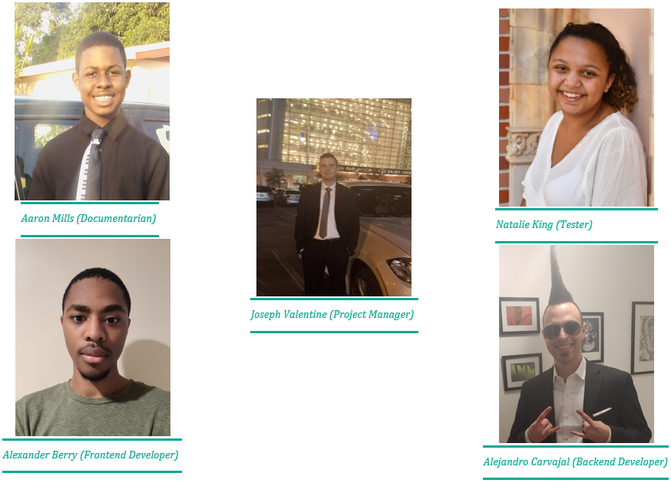

User Guide

1. For users to gain access to the site, they must enter their username and password. An error message will be displayed if user information is incorrect.

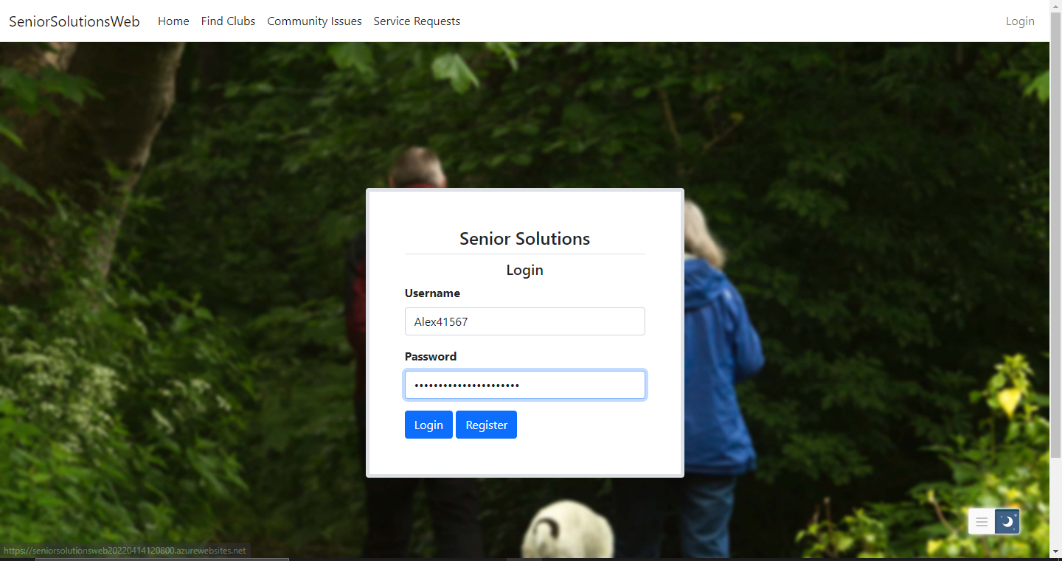

2. Before the user is able to login, they must have an account. This is the registration page.

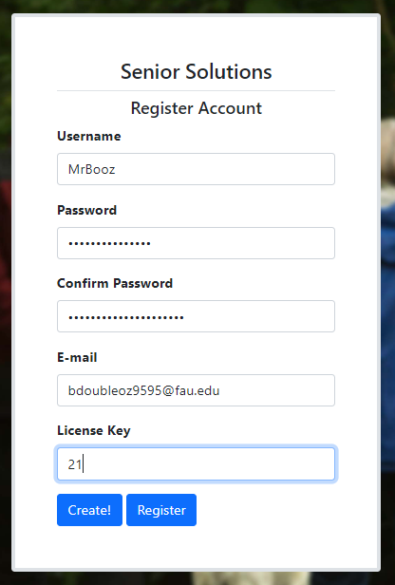

Make sure that the passwords length match!↑

3. Upon logging, an account page will be visible. Note that residents’ and managers’ pages may have varying features. If you are a resident, your page will look like this. 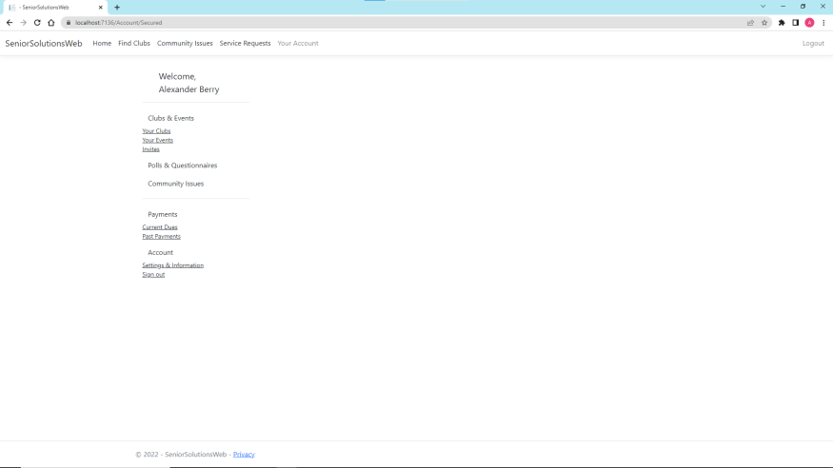

4. The resident’s account page will have a plethora of functionality. Residents are able to host and view a multitude of clubs!

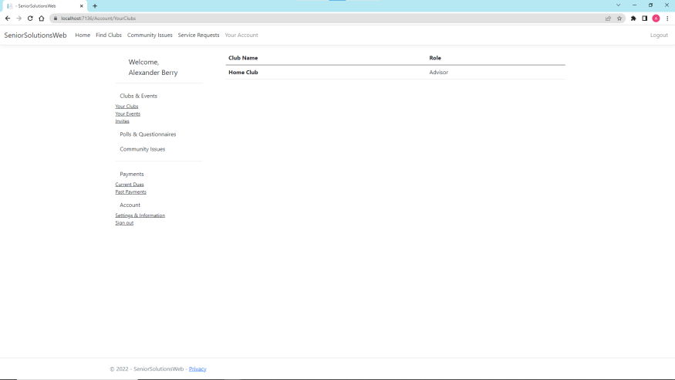

5. Users may also be invited to clubs and events!

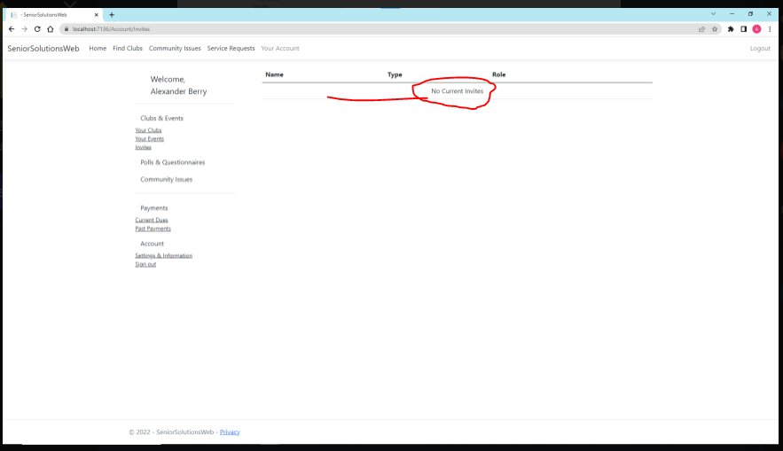

6. Additionally, users can view payments and available funds in their account. They can view past payments, too.

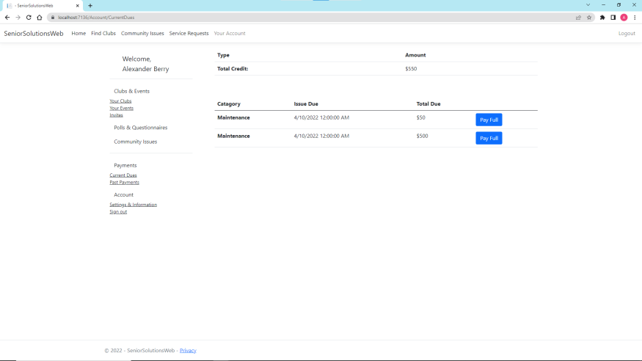

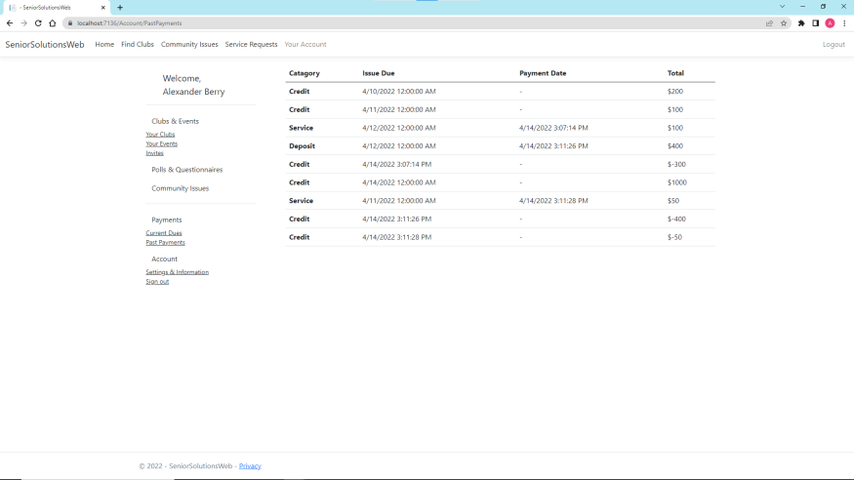

7. Community issues is where residents can post on community issues. You can click arrows to vote or choose to comment, edit, or delete posts. Of course, you can only edit and delete your own post! Note that the green arrows are positive votes while red is for negative.

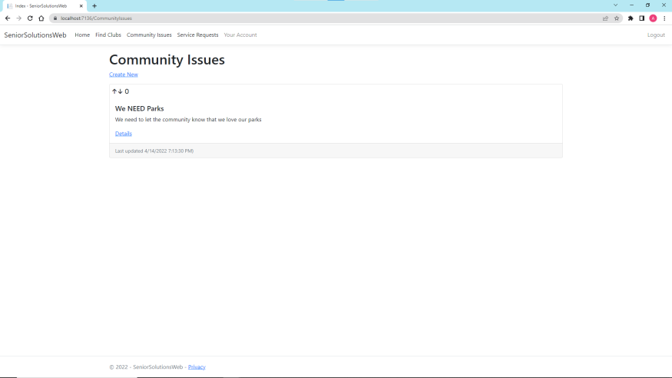

8. Finally, if for some reason, you have forgotten or dislike your user login information, you can view or change it!

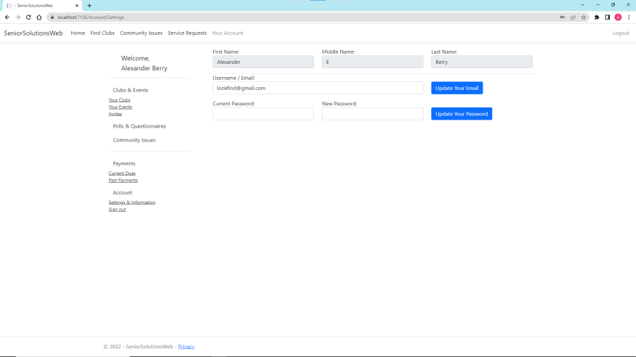

**JOSEPH VALENTINE**

Coconut Creek, FL 33073

(954) 608-5778 | Joey.valentine22@gmail.com

**QUALITY ASSURANCE | RISK MANAGEMENT | PEER LEADERSHIP**

**KEY HIGHLIGHTS**

* **Highly Skilled:** Proven track record for leading multi-dimensional teams in high pressure, high tempo environments on schedule.
* **Strengths:** Leadership, management, oral and written communication, and interpersonal skills. Thrive in both independent and collaborative work environments. Skilled at developing and cultivating key relationships and establishing effective collaborations.
* **Motivated Learner:** Demonstrated ability to assimilate to new ideas, concepts, methods, and technologies. Dedicated and innovated team builder with a superior work ethic.

**PROFESSIONAL EXPERIENCE**

**Broward College – Davie, FL 2018 – 2020**

Veterans Services Work Study Representative

* Assisted veterans in the admissions process for Broward College.
* Educated potential veteran students on what benefits and services were available.
* Efficiently documented confidential information.

**United States Army – Various Locations 2014 – 2017**

Combat Engineer

* Evaluated supply chain operations, implementing improvement solutions; increased the accuracy and efficiency of inventories by 60% by keeping organized locations of items
* Trained over 2K students at West Point, NY on mathematical calculations involved in engineering; used personal experience and knowledge to train and educate personnel in the proper use, maintenance, and accountability of equipment
* Provided technical support and led team coordination during maintenance and operations troubleshooting; developed and implemented timely and cost-effective solutions
* Provided training to 4 team members on operational expectations, protocol, and procedures to ensure compliance with regulation and workplace safety; conducted daily risk management evaluations, implementing strict safety measures which resulted in no injury incidents
* Ensured the maintenance and accountability of more than $500K of critical equipment and materials with no incidents
* Reviewed and revised operations, implementing process improvement techniques to expedite the completion of tasks and providing performance evaluations to guide personnel success

**EDUCATION**

**Broward College – Davie, FL**

A.A. received December 2019

* Vice President of Broward College Student Veterans Association
* Honor Roll recipient

**Monarch High School – Coconut Creek, FL**

Graduated June 2014

* JROTC leadership role for 2 years

**TECHNICAL SKILLS**

**Software**: Microsoft Office, Access, Word, Excel, PowerPoint, OneNote, Outlook, Project, InfoPath, SharePoint

**Operating Systems**: Mac / Microsoft Windows

**Aaron P. Mills**

Fort Lauderdale, FL **∙** (954) 381-6438 **∙** [millsa2020@fau.edu](mailto:millsa2020@fau.edu)

<https://www.linkedin.com/in/aaron-mills-69005920a/>

**EDUCATION**

College Academy at Broward College

Associates of Arts and Highschool Diploma Spring 2020

Florida Atlantic University

Bachelor of Science in Computer Science *TBD…*

Certificate in Data Science *TBD…*

GPA: ≈3.80/4.0

**TECHNICAL SKILLS**

Programming Languages: Assembly, C, C++, C#, Python 3, MATLAB, HTML5, CSS, JavaScript

**ACADEMIC PROJECTS**

**Documentation for Senior Retirement System** (Principles of Software Engineering , Spring 2022)

I wrote documentation for senior system retirement project. This smart system is meant to automate the senior retirement home community experience, with implementations of databases and servers written mostly in C#. Documents include diagrams, research paper, statements, and more.

**Neural network Implementation** (Introduction to Deep Learning, Spring 2022)

I implemented neural networks in Google Colab using Python. The networks were built to classify Spotify tracks as “Top 100” worthy or not based on previous records and 15 features extracted from the samples. This project required me to split data into validation, testing, and training sets; understand matrix manipulation, libraries and inputs, and reading some documentation in order to optimize my neural network implementation.

**Website to host Mini-Projects** (Introduction to Internet Computing, Fall 2021)

I created webpages that acted as my portfolio as well as a calculator and a Tic-Tac-Toe game. This required HTML, CSS, and Javascript. From these projects, I learned to implement forms, retrieve user input, upload images, use Bootstrap, implement buttons and links, connect webpages, and more.

**CLUBS/ORGANIZATIONS**

Tau Beta Pi

**WORK EXPERIENCE**

None

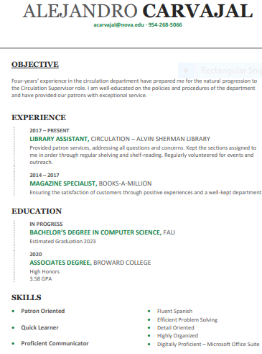

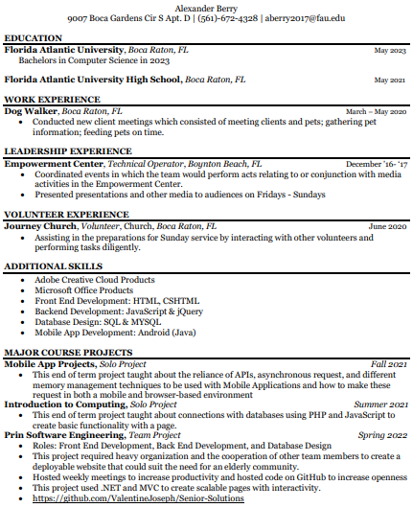

**Natalie King**

1353 SW 26th Ave. Deerfield Beach FL, 33442

Nataliek0630@gmail.com

(561) 989-4183

**OBJECTIVE:** To enroll in a university that not only will help me in my academic endeavors, but will help me establish my worldview and grow as a person.

**EDUCATION:**

* Florida Atlantic University High School.

Boca Raton

* + High school diploma May 2021
* Florida Atlantic University
  + Enrolled Fall 2021

**SKILLS:**

* Certified in Microsoft Office
* Verbal and written communication English and Spanish (proficient).
* Certified in beginners short-term child care.
* Certified in food safety
* Proficient in JavaScript and C++
* Certified in CPR

**RELEVANT EXPERIENCE:**

* Tutoring K-8  2018-2020 *AD Henderson University School Boca Raton* 
  + Assisting elementary and middle school students in completing homework.

➢ Clarifying learning subjects for students of various ages and levels.

* Speech and Debate 2018-Present *AD Henderson University School Boca Raton* 
  + Collecting and organizing evidence to present/ persuade an audience.

➢ Developing inclusive arguments to debate on a public platform.

* Student Teacher 2016-2018 *Boca Dance Studio. Boca Raton* 
  + Motivated 9-11 year old students to try their hardest.

➢ Maintained a stable class of 20 kids for 3 hours.

* + Collaborated with others to ensure maximum benefits were achieved.
* Volunteer Note-taker 2019-Present *Florida Atlantic University Boca Raton* 
  + Helped to facilitate inclusion in the courses at Florida Atlantic University
  + Provided learning resources for disables students so that they could have an equal opportunity with learning.

Research Paper

**Smart Systems for Seniors**

Joseph Valentine, Aaron Mills, Alejandro Carvajal, Alexander Berry, Natalie King

### **Abstract**

         This research paper shall primarily be focused on smart systems with respect to seniors. The introduction shall inaugurate referenced definitions, establish the context and domain, and present the basis of the research. After which, usage factors that affect seniors’ choices to use smart devices will be discussed. Once essentials are covered, three types of smart technologies shall be analyzed. During this process, benefits and consequences to contraption usage will be conveyed, as well as the mentioning of possible examples or forms of the device. Finally, a conclusion will reside at the end to summarize the facts and deduce logical inferences to how engineers should address the aging population during smart system development.

### **Introduction**

As humans age, our bodies grow to increase in fragility. Some tools proven useful in the past may deem themselves a liability for the future, whether the tool be man-made or part of the human body. As time continues, the portion of the human population of seniors is predicted to increase due to expanding research (Sapci et al.).  Being prone to the struggles of aging, these adults require quality equipment to assist in their navigation of their delicate world. Smart systems are technologies that utilize sensors and controls to enact seemingly intelligent decisions based on the data collected. This could include the automation of household chores or devices which act independent of human intervention. Within this paper, we shall discuss the research of unique smart systems and how such creations impact the livelihood of seniors.

### **Usage Factors**

         In relation to seniors, it’s important to consider the factors enabling and discouraging them from using smart systems, as most are not particularly fond of such gadgets. One could argue that there exist mountains of research supporting more mature adults’ adoption of smart technology, more than there is for the young, yet there currently lies a massive gap between the two groups (Jenna et al.).

         One essential limiting factor diminishing elders’ smart gadget usage is the complexity. Most citizens of such an age despise having their time wasted and enjoy peace. When devices appear offering a plethora of unique features, a fraction of which are brand new and some slight variations of what other systems have, the contraptions can seem daunting. It is not uncommon to find an ancestor struggling due to a system not performing or responding as intended. Situations such as these are counterproductive and will repel the desired target. Implementations which cause convolutedness to soar include strict security, misleading instructions, and a counterintuitive user interface.

         The other relevant deterring influence towards smart device usage would be the lack of trust. When discussing smart machines, the iconic example that comes to mind is the smartphone, the bulk of which has been adopted by the younger generations. Smartphones have brought so much usefulness that they have often been referred to as pocket computers, handheld computers, and mini-computers. Despite the positivity, research has shown that excessive smartphone usage could lead to mental illness, stress, and codependency (Harwood et al.). Being the most revolutionary smart system to this date, elders watch how their predecessors and peers are affected by the technology and opt out of the involvement. Many fear their privacy and data will be taken advantage of by the creators in an attempt at emotionally manipulating and scamming them of their time.

         While smart inventions may seem intimidating at first, there is plenty of research supporting seniors’ adoptions. With risk factors that positively correlate with age, cardiovascular diseases are the number one leading cause of death worldwide (Redfern). Fortunately, there exist research and smart devices that help record data to combat chronic and cardiovascular diseases (Kim et al.). Such technology could store information, utilizing it for recommending workout routines, drug consumption timings, and healthy practices. While bodily functionality decreases, smart contraptions often fill the voids to make seniors’ lives independent and engaging. Developers and engineers should not undermine this detail, as the majority of elders grow fragile and isolated.

### **Wearable Devices**

         Wearable devices are one of the more common archetypes of smart gadgets. Part of the popularity originates from the concept that these devices are convenient, comfortable, and portable. Wearables, as the name implies, are creations designed to be attached to the human body similar to the way clothes are worn. Common forms of this application include watches, bracelets, headphones, headbands, and eyewear.

         A frequent trend among smart wristwear is to track fitness related data. Common features include heart rate, calories, distance, and energy monitoring. Some offer additional features such as sleep tracking, workout animations, and workout analyses. These implementations are particularly useful with respect to the elderly, for they encourage the embracement of healthy lifestyles (Fanvar et al.). This is especially effective when the information being gathered is relayed to healthcare facilities and physicians.

         Bracelets have been proven an alternative option for their smart watch equivalent. Similarly, due to the data collection, the smart bracelets also improve senior healthcare systems and individuals’ health (Jeng et al.). Additionally, research has shown that the technology improves awareness, curiosity, and understanding of smart gadgets, as if it were the gateway to bridging the digital gap between elders and younger generations.  It is important to discover ways to encourage seniors to use smart systems.

### **Smart Homes**

         Smart homes are created through the automation of household tasks using technology’s sensors and artificial intelligence (Maitre et al.). Systems that control lights, fridges, doors, bells, and windows are common appearances of this smart type. Making homes autonomous is a valuable solution to the body utility loss problem most elders grow to have, for elders allocate larger portions of their time (80%) to dwelling at home than other age groups (Wong et al.). The machines can perform the difficult and trivial tasks for them to improve their quality of life.

         A plethora of smart gadgets exist today to improve home automation. There are security implementations that alarm the household when any door or window has been opened, which can be disabled for specified times. Another security system, with access granted to mobile devices, can display video and images of the contents within its camera's view. A common feature of which is to only display the view and send notifications when motion occurs. This is convenient for seniors as they would need not concern themselves with danger awaiting their doors, windows, or other entrances.

         Furthermore, while smart home applications improve security towards the outside world, many also provide protection against oneself and bill collectors. Smart fridges, ovens, and stoves can be set to alarm or shutdown when the device has been activated for too long, and may present indicators of when such gadget is in use. Advancements like these are essential; dementia and memory loss are some of the most critical illnesses impairing seniors’ independence (Sapci et al.).

### **Self-driving Cars**

         Due to growing sensory flaws and body frailness, immobility is one of the strongest detractors from elders’ enjoyment of life (Demiris et al.). Many of previous populations prefer to remain independent, but transportation can seem dangerous and intimidating at older ages. Self-driving vehicles utilize concepts taken from deep, machine, and reinforcement learning to make intellectual decisions. The data is recorded through actuators, sensors, and cameras (known as computer vision) and processed through a series of complex algorithms to swiftly apply optimal driving strategies.

         The interest in self-driving cars stems from convenience. Having a vehicle that safely transports itself saves the elderly from unnecessary stress whilst still providing the opportunity to adventure at will. In addition, self-driving cars can reduce the irritation of shopping and delivery by having products delivered autonomously to the recipients’ home. Though many vessels are not fully automated yet, many companies are conducting research and deploying products, propelling the industry forward. One entity that embraces this practice would be Refraction AI, a company dedicated to automated food delivery. Most notably, Waymo and Telsa are also both notorious for their robotaxi features, which would prove useful to senior transportation.

         Autonomous automobiles are arguably the most revolutionizing technological advancements in the transportation industry. This holds true in part because humans have been illustrated to act as the main catalysts for most (94%) traffic accidents (Liu et al.). Despite this, however, there remains evidence suggesting self-driving vehicles might be more dangerous than the human-driven counterpart. While limiting human interaction may appear optimal, being connected to cloud systems and deploying techniques dependent upon the internet of things implies that this subset of vehicles is susceptible to cyber-attacks. This is unfortunate, especially in reference to the distrust that currently resides among seniors and smart technology mentioned previously. Programmers and mechanics should certainly take cybersecurity into consideration during development.

### **Conclusion**

The senior population is projected to take up a larger percentage of the overall population in the future. Smart systems provide a multitude of benefits for seniors. This provides an opportunity for software engineers to produce technologies targeted at this demographic. Wearables promote healthy lifestyles and engagement via trackers, reminders, and recommendations. Smart technology can assist with daily living activities, such as cleaning and entertainment, and also protect seniors from malicious individuals through smart home security systems. Finally, self-driving cars aid in making elders’ lives more independent and active. Indeed, there are existing smart-systems and smart-devices but these have been adopted more by younger generations. Seniors are more concerned about technologies that help in emergencies as opposed to preventative technologies. This can change through better communication of preventative technologies and their benefits. Elders also worry about ease-of-use, complex outputs, privacy, and security of these devices. In general, smart devices have rich potential to improve seniors’ quality of life; nevertheless, engineers should take cybersecurity, simplicity, comfortability, utility, and ethics into consideration when targeting previous populations. Releasing smart systems that repel seniors would not be smart.

# **References**

Demiris, George, et al. “Senior Residents’ Perceived Need of and Preferences for ‘smart Home’ Sensor Technologies.” *International Journal of Technology Assessment in Health Care*, vol. 24, no. 1, Cambridge University Press, 2008, pp. 120–24, <https://doi.org/10.1017/S0266462307080154>.

Farivar, Samira, et al. “Wearable Device Adoption Among Older Adults: A Mixed-Methods Study.” *International Journal of Information Management*, vol. 55, Elsevier Ltd, 2020, pp. 102209–102209, <https://doi.org/10.1016/j.ijinfomgt.2020.102209>.

Harwood, Joshua, et al. “Constantly Connected – The Effects of Smart-Devices on Mental Health.” *Computers in Human Behavior*, vol. 34, Elsevier Ltd, 2014, pp. 267–72, <https://doi.org/10.1016/j.chb.2014.02.006>.

Jeng, Mei-Yuan, et al. “Analyzing Older Adults’ Perceived Values of Using Smart Bracelets by Means-End Chain.” *Healthcare (Basel)*, vol. 8, no. 4, MDPI AG, 2020, p. 494–, <https://doi.org/10.3390/healthcare8040494>.

Jenna Jacobson, et al. “Aging with Technology: Seniors and Mobile Connections.” *Canadian Journal of Communication*, vol. 42, no. 2, Canadian Journal of Communications Corporation, 2017, p. 331–, <https://doi.org/10.22230/cjc2017v42n2a3221>.

Kim, Ben Yb, and Joon Lee. “Smart Devices for Older Adults Managing Chronic Disease: A Scoping Review.” *JMIR mHealth and uHealth*, vol. 5, no. 5, JMIR Publications, 2017, pp. e69–e69, <https://doi.org/10.2196/mhealth.7141>.

Liu, Peng, et al. “How Safe Is Safe Enough for Self‐Driving Vehicles?” *Risk Analysis*, vol. 39, no. 2, Wiley Subscription Services, Inc, 2019, pp. 315–25, <https://doi.org/10.1111/risa.13116>.

Maitre, Julien, et al. “Recognizing Activities of Daily Living from UWB Radars and Deep Learning.” *Expert Systems with Applications*, vol. 164, Elsevier Ltd, 2021, <https://doi.org/10.1016/j.eswa.2020.113994>.

Sapci, A. Hasan, and H. Aylin Sapci. “Innovative Assisted Living Tools, Remote Monitoring Technologies, Artificial Intelligence-Driven Solutions, and Robotic Systems for Aging Societies: Systematic Review.” *JMIR Aging*, vol. 2, no. 2, JMIR Publications, 2019, pp. e15429–e15429, <https://doi.org/10.2196/15429>.

Redfern, Julie. “Can Older Adults Benefit from Smart Devices, Wearables, and Other Digital Health Options to Enhance Cardiac Rehabilitation?” *Clinics in Geriatric Medicine*, vol. 35, no. 4, Elsevier Inc, 2019, pp. 489–97, <https://doi.org/10.1016/j.cger.2019.07.004>.

Wong, Johnny Kwok Wai, et al. “Technical Requirements of Age-Friendly Smart Home Technologies in High-Rise Residential Buildings: A System Intelligence Analytical Approach.” *Automation in Construction*, vol. 73, Elsevier B.V, 2017, pp. 12–19, <https://doi.org/10.1016/j.autcon.2016.10.007>.